40 Book Challenge
Your mission this year is to read a total of 40 books!
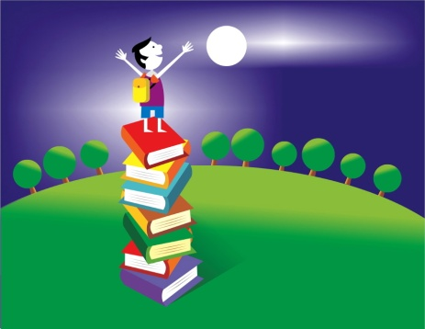
Did you know that reading makes you smart? My goal is for you to become as smart as you can this year and it all starts with reading. This year you will be given at least 20 minutes at school to read. Also, you should be reading 20 minutes at home each night. That is a total of 200 minutes each week.
Can it be done? OF COURSE. But YOU have to make it happen. Start reading now!
Parents, here are some tips to help your child rise to the challenge:
· Talk with your child about the books they read
· Have your child read aloud to you or to a sibling
· Take them to the public library
· Encourage your child to start a book club with friends
Genres for Challenge
Your choice (must be a good fit book)- 10
Mythology - 2
Poetry Anthology - 1
Biography or Autobiography - 2
Historical Fiction - 3
Realistic Fiction - 2
Informational Text - 3
Mystery - 2
Fairy Tale - 1
Folktale - 2
Tall Tale - 1
Fable - 1
Cultural - 5
Graphic Novel - 1
Fantasy - 2
Science Fiction -1
Newbery Honor or Winner – 1
_______________________________________________________________________
Parent:____________________________
I have seen and read this sheet and will encourage my child along their journey to 40 books
Student:__________________________
I will take the challenge which will make me even smarter!

